FEMINISM REFLECTION THROUGH FAMILY COMMUNICATION IN THE MAIN CHARACTER OF LITTLE WOMEN MOVIE
Yanti Rosalinah ¹⁾, Ibnu Subroto²⁾, Rina Lestari³⁾
Universitas Bina Sarana Informatika ¹⁾, yanti.yaa@bsi.ac.id
Universitas Bina Sarana Informatika ²⁾, ibnu.isb@bsi.ac.id
Universitas Bina Sarana Informatika³⁾, rina.rls@bsi.ac.id

ABSTRAK
Tulisan ini dimaksudkan untuk memahami bagaimana Jo march yang merupakan pemeran utama wanita digambarkan dan bagaimana film tersebut mencerminkan nilai-nilai feminis melalui karakter Jo march. Analisis dalam teks ini menggunakan pendekatan feminis karena tujuan dari penulisan ini adalah untuk menemukan feminisme pada tokoh utama dan bagaimana komunikasi dalam keluarga mempengaruhi segala keputusan yang diambil oleh tokoh utama dalam film ini. Analisis ini didasarkan pada sumber film Little Women karya Greta Gerwig. Metode analisis yang digunakan adalah metode deskriptif kualitatif. Untuk menemukan nilai feminisme tokoh Jo March, ada tiga rumusan masalah dalam tulisan ini. Masalah pertama adalah mengetahui tipe feminisme yang ditunjukkan oleh tokoh utama, Jo March. Kedua, bagaimana sudut pandang perempuan yang ditampilkan dalam film Little Women. Terakhir. Bagaimana komunikasi dengan keluarga mempengaruhi sisi feminism dari tokoh utama. Analisis menunjukkan bahwa: (1) dalam film Little Women, tokoh utama menampilkan dua jenis feminisme, yaitu feminisme liberal dan feminisme Marxis. (2) Cara pandang terhadap perempuan, dimana perempuan pada waktu itu dibatasi oleh pemikiran bahwa mereka harus menikah untuk mendapatkan kehidupan yang baik. (3) Keluarga memiliki peran yang sangat penting untuk membangun pola pikir seseorang..
Kata Kunci: Feminisme, komunikasi, Tokoh Utama, Film

ABSTRACT
This paper is meant to understand how Jo march, who is the female lead character, is portrayed and how the film reflects feminist values through the character of Jo march. The analysis in this text uses a feminist approach because the purpose of this writing is to find the feminism of the main character and how communication in the family affects all the decisions taken by the main character in this film. This analysis is based on the sources of Little Women movie by Greta Gerwig. The method of analysis used is a qualitative descriptive method. To find the feminism values of the Jo March character, there are three problem formulated in this paper. The first problem is knowing the type of feminism shown by the main character, Jo March. Second, how is the point of view of women shown in the Little Women movie. And last how does communication with family affect the feminism side of the main character.. Analysis showed that: (1) in the film little women, the main character featured two types of feminism, which is liberal feminism and Marxist feminism. (2) The point of view toward women, which women at that time were limited by the thought that they should marry in order to have a good life. (3) Finally, Family has a very important role to build a person's mindset.
Keyword: Feminism, Communication, Main Character, Movie

INTRODUCTION
Literature is a human expression in written or spoken form based on thoughts, experiences, opinions, feelings in an imaginative form, reflecting reality or data wrapped in aesthetic content through the medium of language. Literature is a work of written art compared with other ordinary writing has various characteristics of excellence, authenticity, art, beauty, content and expression. The literary work itself is a well-scored essay in beautifully aesthetic language. Literature also gives common knowledge and insight about human, social, intellectual, with distinctive and unique styles.
Movie is a literary work of living pictures that are played to produce the illusion of motion pictures that are presented as a form of entertainment. Using visual art to make the movie as medium of communicating the feelings, ideas, views, experiences, perspective, and moral messages.
The main character is the central character of the story action theme and the guide to the story line. The main character is a protagonist whose conflict with antagonists may lead to a conflict of stories. And the minor character is a character to illuminate or highlight the main character.(Siagian et al., 2018). The main character is always associated with a story conflict and is an intrinsic component of the story, being the most stealing character of the audience, the main character is often either good character or protagonist.
Feminism is an ideology and social movement in an attempt to achieve equality for women in various areas of life. Social, political, personal and economic equality that can be interpreted in broad ideology. The patriarchy that spawned awareness of the inequality and discrimination that women experience is the background of this feminist movement.
Family communication encompasses the social dynamics in a family system, influenced by a variety of factors. Identify examples of how culture, gender, and technology all interact with family communication.
People connected to each other are, at the most fundamental level. Across the world, families look different but they do have a few things in common. For one, they can all drive us crazy and, for two, they all have unique systems of communication. People communicate with all sorts of other people throughout their lives but those communications are always distinct to that relationship. People communicate one way with friends, one way with co-workers, another with strangers. But families communication may be the most important of all. Many social scientists consider the family to be the base unit for all of society, the building block of all social relationships.

THEORETICAL REVIEW
Literature
Literature is an image born from the creative mind of the writers that is transformed into art. Writers are often inspired by the various aspects of life and the problematic ones depicted by literature. Literature is a personal expression of human feelings of the experience, thought, feeling, ideas, belief, which can excite charm with language and be portrayed in written form. Literature is used by writers in conveying opinions to express about life according to (Juni Ahyar, S.Pd., 2019) ” Literature is a means of shedding ideas or thoughts about life”. Literature is also a universal language art interested in characteristics or essential features as poetry, novels, history, biography, drama, or movie.
A movie is a literary form, movie is the media information most accessible to everyone. It is not uncommon for a movie to be a medium to communicate a moral message to the people according to (Permana et al., 2019)”Movie can be viewed as a human creation containing a high aesthetic, or it can also be viewed as a medium of communication, where it can be used as a medium to express and disseminate messages from filmmakers to the public”. It includes the application of moral values or the mindset of an object that becomes the story in a movie.
The story in a movie is usually based on a reflection of human life, so it is expected to be able to grasp the morals behind the story. Little Women Movie by Louisa May Alcott may be a movie that tells about women lives after the civil war in America. Little woman movie is about struggle, sacrifice, love, and family, and in it has strong of feminism.

Feminism
Feminism is a complex body of ideology and theory, striving at its core to achieve social, political, and economic equality for women and men. according to (Aliyah et al., 2018) “The feminist theory is a theory of social life and human experience from the perspective of women”. Feminism refers to a diversity of beliefs, ideas, movements, and agendas. It refers to any action, particularly that is organized, that encourages changes in society to end the harmful patterns of women (Alwafi Ridho Subarkah, 2018) ”Feminism then changes the demands that are detrimental to women”.
Feminist communication theory, which is an approach or concept for understanding and explaining gender, rejects answers and assumptions — unreasonable assumptions about the existence of women. In addition, it is asserted that women urgently need to change the structure to give birth to new social relationships and a just society. (Rakow and Wackwitz, 2004: 6)
According to Bowers (2004) stated, starts the feminism definition by stating that feminism is known as the women movement and woman view based on the literary works. Feminism is a political attitude and movement that call for the status, rights and desire of women to be taken into consideration in all aspects of life (Siagian et al., 2018). Based on the above opinion, feminism is known as a movement to demand balance of rights for women. This movement is often claimed to be an act based solely on the desires of women, but in reality feminist movement is humanitarian movement. According to Angela Davis said: “Feminism involves so much more than gender equality. And it involves so much more than gender,”(Vergès, 2021) this statement asserts that feminism is not just a movement based on gender.
Type of Feminism
1) Liberal feminism
Liberal Feminism was born first formulated by Mary Wollstonecrat in her writing A Vindication of the Right of Women (1759-1799) in the 18th century and in the 19th century by John Stuart Mill in his book Subjection of Women, then in the 20th century Betty Friedan in The Feminism Mistique and The second Stage . Liberal feminism is an understanding that base its thinking on liberal concepts that emphasize that men and women are created equal and have equal rights and should have equal opportunities.
Liberal feminism wants a just society order, all regulations that are enforced because of the element of coercion must be removed, the hierarchical system of gender and forced traditional gender roles must stop (Baehr, 2017). Liberal feminism wants freedom for women from oppressive gender roles. The inherent role of women and is used as a justification to place women lower than men in all social spheres. This ideology also allows women to choose roles in the public sphere rather than choosing to follow the image of the ideal woman that society wants, getting married and becoming a housewife.
2) Marxism Feminism
Feminism Marxists viewed the problem of women in the terms of capitalism as a source of female oppression. It is based on economic theory of Marxists.
Marxist feminists believe that women's work shapes women's thinking and therefore shapes women's nature. They also believe that capitalism is an exploitative system of power relations.(Siagian et al., 2018). It can be interpreted as a transactional relationship that is basically exploitative. A worker will continue to work for wages, while an employer will continue to force workers to work harder without the possibility of increased wages.
Feminism Marxists see the position of women from an economic perspective, the subordinate position of women under men is rooted in economic dependence. In fact the secondary status of women is based more on economic problems than on social and cultural issues. It can also be prospered in a society with certain cultures, if women is economically dominant over the male, and thus occupy a superior position over the male (Lisa, 2017).
3) Radical Feminism
Radical feminists are based on the fact that gender inequality is the basis of all inequality and oppression. The repression of women occurs in the patriarchate system, which is the hierarchical system of male dominance over female (Vukoičić, 2017). Radical feminism is a feminist way of looking for radical change in society by eliminating all forms of social and economic supremacy in men. Radical feminists want to eliminate patriarchy that harms women by opposing prevailing social norms and institutions through the political process. Some examples are challenging the sexual objectification of women, challenging traditional gender roles, and raising public awareness about issues such as sexual harassment and violence against women.
4) Postmodern Feminism
Postmodern feminism began in the early 1980s with a merging of post-feminism terms that have been viewed as critical in many of the feminist theories of the past, particularly of the second wave of feminism. The objective of postmodern feminism is to destabilize deep-rooted patriarchies in society that cause gender inequality. In the postmodern feminist mind to challenge and avoid an essential definition of femininity propagated during the modern feminist period.
5) Socialist feminism
Socialist feminism became better known in the 1970's. This theory represents a theoretical and practical approach to achieving gender equality. This theory analyzes relationships of bullying of women and other oppression in society, such as discrimination, racism, and economic injustice. Socialist feminists sought to create a more equal society, eliminating the exploitation of the poor through capitalism. This theory would like to integrate gender discrimination recognition in their work to achieve justice and equality for women, for the working class, for the poor, and for all mankind.
6) Postcolonial Feminism
According to Weedon states that, Postcolonial feminism seeks to account for the ways that racism and the long-lasting political, economic, and cultural effects of colonialism affect non-white, non-western woman in the postcolonial world (Halim, 2017). Postcolonial feminism was part of the feminism that developed in the 1980's. This theory focuses on the problems women experience in western culture. In hopes that women's marginalization which occurred because the legacy of colonization could be seen and identified as a humanitarian problem.
7) Anarchist Feminism
Anarchist feminism arose in the late 19th century, which argued that traditional gender and patriarchy as a manifestation of the coaggressive hierarchy must be replaced by decentralized free associations. Anarchist feminism is an anti-authoritarian, anti-capitalist, anti-oppressive philosophy with the aim of creating basic equalities between genders. Feminism demonstrates social freedom and women's freedom without the reliance required on groups or other parties
Communication
In addition, research by Pramono et al. (2016) explained that adolescent family communication patterns affected on adolescent learning achievement and emotional intelligence. The better communication between adolescents with their parents, the better academic achievement and emotional intelligence adolescents can be obtained. Some of the results of these studies indicate that positive communication is one of the factors supporting the success of families in realizing a harmonious family and minimizing the problem of juvenile delinquency.
As Fitzpatrick and Koerner (1997) emphasized, “family communication en-vironments differentially foster the development of various functional communi-cation skills” (p. 1). Family communication exposes children to a set of fairlyconsistent interaction patterns and strategies, depending on their own family’scommunication climate. It is through the conduit of FCC that norms and patternsare established, sustained, and modified (see Perse, 1994).
Sering ditemui didalam keluarga inti dimana didalamnya terdapat ayah, ibu, kakak dan adik tentu terdapat berbagai macam perbedaan dalam pola komunikasi. Pola komunikasi dapat dipahami sebagai pola hubungan antara dua orang atau lebih dalam pengiriman dan penerimaan pesan dengan cara yang tepat sehingga pesan yangdimaksud dapat dipahami. (Often found in families where there are father, mother, brother and sister of course there are various kinds of differences in communication patterns. Communication patterns can be understood as a pattern of relationships between two or more people in sending and receiving messages in an appropriate way so that the intended message can be understood. (Djamarah, 2004:1).

DISCUSSION
Types of Feminism in the Little Women Movie
Feminism is a social movement that demands equal right for women in all areas of life. There are seven type of feminism in previous theory, but the writer only find two types of feminism in the movie there are Liberal feminism and Marxism feminism.

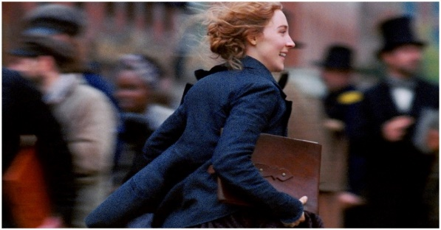
- Liberal Feminism

Figure III.1. When Jo March Go to New York
(01:45:13 – 01:45:35).
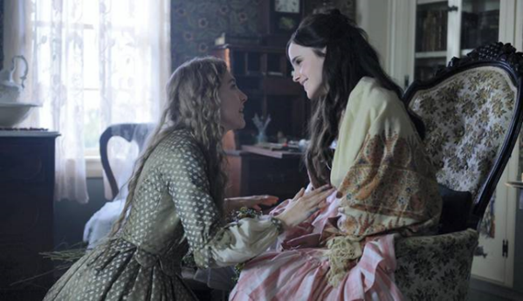
In this scene, showing Jo walking in a busy street, she went to New York to pursue his dream of becoming a great writer and leave her family in concord, Massachusetts. She went alone to New York with the will, the vigor and the motivation from her family.

Figure III.3. When Jo told to Meg to not get marriage
(01:31:34 – 01:31:55)
Meg March : Jo? What’s wrong?
Jo March : we can leave, we can leave right now. I can make money, I’ll sell stories, I’ll do anything, I’ll cook, I’ll clean, I’ll work in factory, I can make life for us.
Meg March : Jo …
Jo March : and you should be an actress, you should live on the stage. Let just run away together.
Jo tried to talk to his sister who suddenly decided to get married and start a family life, Jo gave the life choice that his sister originally wanted, her dream, her desire to become a famous artist. Jo will always protect and support her sister's dream. According to the scenes above, the main character, Jo march, is seen unlike most women in general, she choosing to be a career woman rather than following another woman who marrying and raising children. She'd rather follow her dreams and Jo wants her sister to do the same. And this action includes liberal feminism, where these ideologies allow women to choose a role in public spaces rather than being the ideal women that society wants, get married and become housewives. From this scene also seen good communication between Jo and his sister.
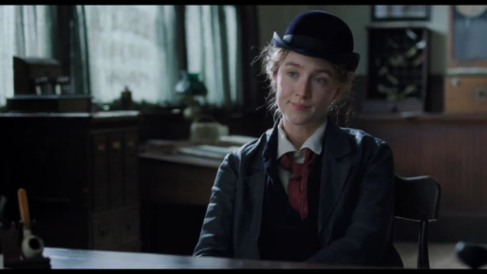

Figure III.6. When Jo with want to put her name in her own Book
(02:05:45 – 02:06:18)
In the scene above, Jo returned to the publishing office in New York to meet Mr Dashwood. They're negotiating compensation for the book Jo just wrote. In her conversation over Jo firmly offered the appropriate price for her book, but Mr Dashwood kept trying to lower the offer, but Jo declined and kept on holding the bid she made. After some debate they came to a fair deal for both sides. Moreover, unlike the scene before where Jo hid her identity as a writer. In this scene Jo courageously said "I want to own my own book" which meant she wanted to announce to the world that she was a writer. She ended up writing a book with title "Little Women" and Jo's actions include Marxism feminism.

The Point of View toward Women Shown in the Little Women Movie
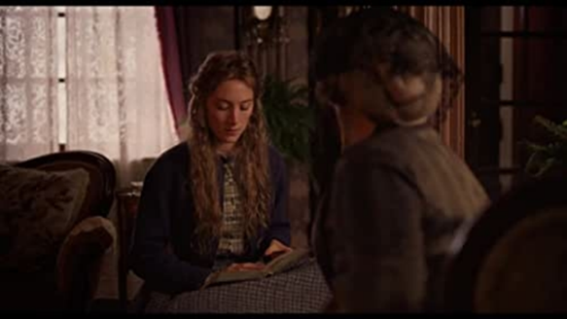

Figure III.7. When Jo said that she will make her own way
(35:17 – 35:35)
In this scene, aunt march told Jo that she should marry a nice, rich man. Because for women the only way to get a good life is to get married. It tells audiences how the public thinks about women at that time. Old thoughts like aunt march have been embedded in people's minds, too. Where society restricts the independent movement of women with that kind of thinking.
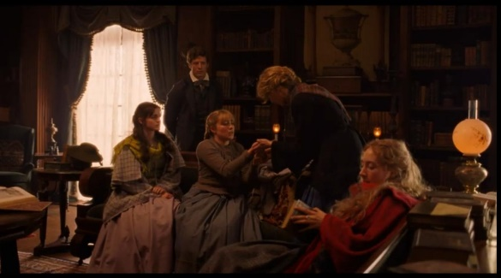

Figure III.8. When Amy get hurt because her teacher hit her
(39:25 – 39:38)
In this scene, Amy is injured in her hand due to being hit by her teacher, Amy cries in front of Laurie's house because she does not dare to go home. Laurie also told Amy to come to the house and treat her wound, not long after that the March family came to pick up Amy. From the dialogue above, John expresses his views on women, according to him it is better for women to study at home because schools for women are very bad, both in terms of facilities and teachers. In addition, most people also think that it is better for women to stay at home than to go to school.

The Main Character Reflects Feminism in the Little Women Movie
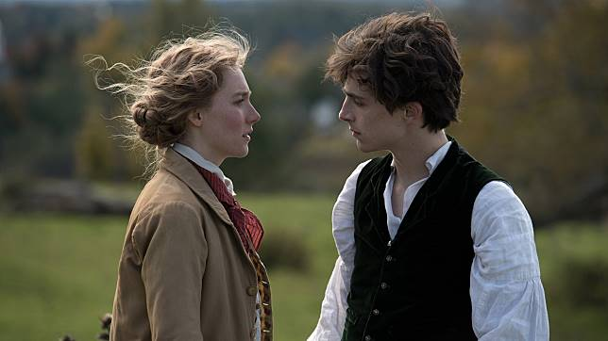

Figure III. 10. When Jo reject Laurie
(01:37:55 – 01:39:10)
In this conversation, Jo rejected Laurie's proposal. Jo wanted Laurie to find a better woman than her, who could love him better. Jo expected Laurie's happiness more than anyone. Jo told to Laurie that they would not be happy together and would only regret it one day. Jo also says she loves herself and the freedom that she has. Jo is a woman who has a dream and loves freedom and doesn't want to lose everything just to marry Laurie.

Figure III.11. When Jo told To Marmee about her feeling
(01:42:20 – 01:42:48)
In this scene, after Beth's death, Jo is so sad that she feels despondent and lonely. Her dream of being a famous writer had not yet come true, her love story ended badly, and now she had lost his sister. In the above conversation, Jo told Marmee that she might make a mistake by rejecting Laurie's proposal and Marmee asked her if Jo loved Laurie, Jo replied that the most important thing was that she would be loved. Marmee tells Jo that it is not the same as loving, and then Jo expresses her feelings she says that women have minds, souls and hearts, women have ambitions, talents and beauty, and she is sick with people who constantly dictate that love is everything to women.
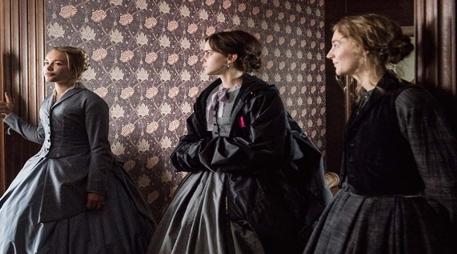

Figure III.12. When Jo want to open the school
(01:55:06 – 01:55:20)
After aunt march died and left a legacy of a big house, her three March sisters, Jo, Meg, and Amy came to the house to discuss what to do with the inheritance that aunt march left behind. There Jo said she wanted to open a school, because the March sisters.
The communication process that occurs between the main character and the family can help form the feminism character of the main character. Good communication patterns can form courage, strength and resilience to various life situations.
CONCLUSION
The main character in little women movie can prove that a woman can be independent, independent enough to allow her to live in her own way and not be a burden to her family. Jo march reflects feminism by opposing the stereotypes of women, who say that women can only live well by marrying rich men. She rejected the stereotypes by proving she could live well without marrying a rich man. Jo march shows her worthiness as a woman to engage in public sphere, by being a writer and publishing her book. She demonstrated his ambition, talents, and intelligence without being hampered by women's limitations based on sexist and patriarchate. Jo march shows that women can be equal to men in the private and in the public sphere.
In the little women movie, the writer have found that the causes of feminism are stereotypes that say that women can only live well by marriage, thoughts of society restricts women based on sexist and patriarchate, and that discrimination against women in various areas of life is the reason for the birth of feminism. Feminism is born on the basis of a refusal of all injustice to women. Giving women the opportunity to participate in public Spaces, letting women live their own lives, giving women the freedom to choose, and granting equal rights between women and men is the purpose of feminism. Feminism can be well reflected through the main characters in little women.
Our character is made up of our habits. Habits formed during childhood and adolescence often persist into adulthood. The formation of a person's character involves three institutions, namely family, school and community. Communication will not work well if you ignore one institution, especially the family. Communication has an important role in the process of forming one's character. This is because the family is an environment for the growth and development of children from an early age to adulthood.
As happened to the main character of the film Little Women. The strong character of a woman named Jo who has the desire to become a famous writer even though she understands enough about the difficulties that will be experienced to achieve it all. The strong determination and courage that grows within the main players cannot be separated from the influence of the family, mutual support for each other, trust in the life choices that have been taken from each family member and good communication between each other.

BIBLIOGRAPHY
Aliyah, I. H., Komariah, S., & Chotim, E. R. (2018). Feminisme Indonesia Dalam Lintasan Sejarah. TEMALI : Jurnal Pembangunan Sosial, 1(2), 140–153. Https://Doi.Org/10.15575/Jt.V1i2.3296
Baehr, A. R. (2017). A Capacious Account Of Liberal Feminism. Feminist Philosophy Quarterly, 3(1). Https://Doi.Org/10.5206/Fpq/2016.3.4
Ballakrishnen, S. S. (2021). Accidental Feminism Gender Parity And Selective Mobility Among India’s Professional Elite (M. L. And J. D. Production (Ed.)). Prince Ton University Press
Elsa, A., Sakti, F., & Weda, S. (2020). The Kind Of Speech Styles In Allan Plenderleith’s “The Bunker (2017)” Movie. 3(3), 376–392.
Fitzpatrick, M. A., & Koerner, A. (1997). Family communication schemata: Effects on children’s resil-iency. In H. McCubbin (Ed.), Promoting resiliency in families and children at risk: Interdisciplinaryperspectives (pp. 1–24). Thousand Oaks, CA: Sage.
Halim, Fia Kurnia. (2017). TYPES AND THE ROLES OF FEMINISM IN THE ANGELOU’S SELECTED POEMS A (Issue 40300112010). ALAUDDIN STATES ISLAMIC UNIVERSITY OF MAKASSAR.
Permana, R. S. M., Puspitasari, L., & Indriani, S. S. (2019). Industri Film Indonesia Dalam Perspektif Sineas Komunitas Film Sumatera Utara. Protvf, 3(2), 185. Https://Doi.Org/10.24198/Ptvf.V3i2.23667
Pramono, F., Lubis, D.P., Puspitawati, H., & Susanto, D. (2016). The influence of adolescent communication patterns to emotional intelligence and learning achievement of senior high school students in Bogor. International Journal of Sciences: Basic and Applied Research (IJSBAR), 30 (1), 121-134.
Lisa, N. (2017). Kedudukan Perempuan Dalam Kumpulan Cerpen Saia Karya Djenar Maesa Ayu (Feminisme Marxis). Universitas Negeri Makassar.
Siagian, F. H., Dirgeyasa, I. W., & Hartoyo, I. (2018). Feminism In Patriarchal Society Reflected In The Main Character Of Perempuan Berkalung Sorban Movie. Linguistica, 7(3). Https://Doi.Org/10.24114/Jalu.V7i3.13287
Vergès, F. (2021). A Decolonial Feminism ‘A. In Journal Of Chemical Information And Modeling (Vol. 53, Issue 9).
Vukoičić, J. (2017). Radical Feminism As A Discourse In The Theory Of Conflict. Социолошки Дискурс, 3(5). Https://Doi.Org/10.7251/Socen1305033v

