Lampiran 1
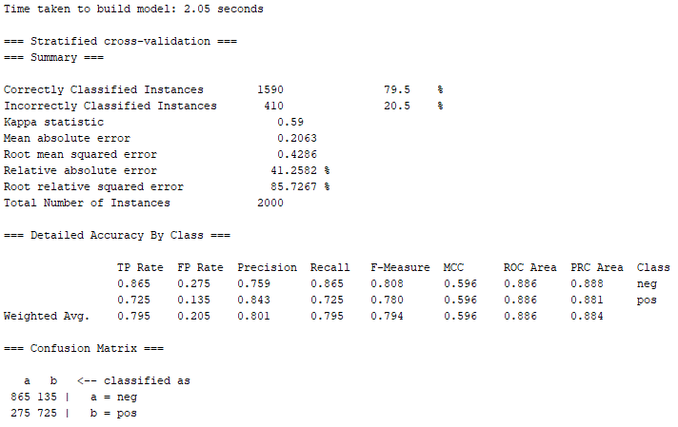
Chi Square + Naive Bayes, 8fold

Lampiran 2
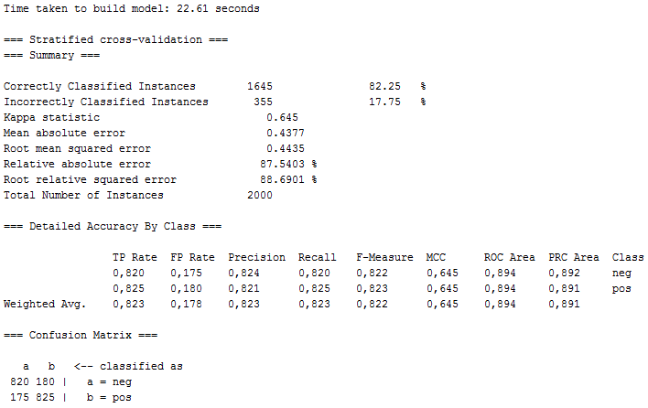
Chi Square + Random Fores Iteration 300, 8Fold

Lampiran 3
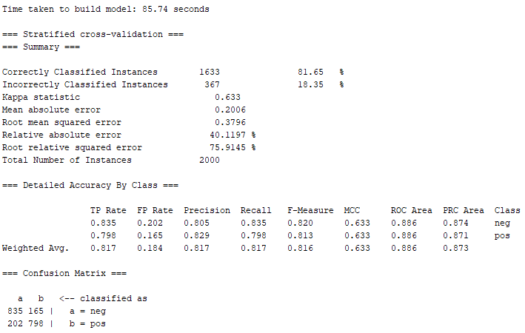
Chi Square + NB + AdaBoost, 8fold

Lampiran 4
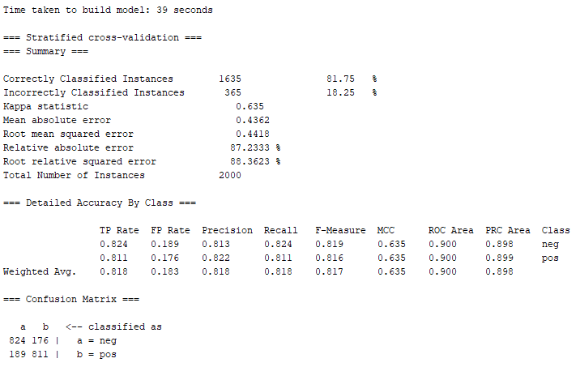
Chi Square + RF Iteration 300 + Adaboost, 8Fold
Lampiran 4.B
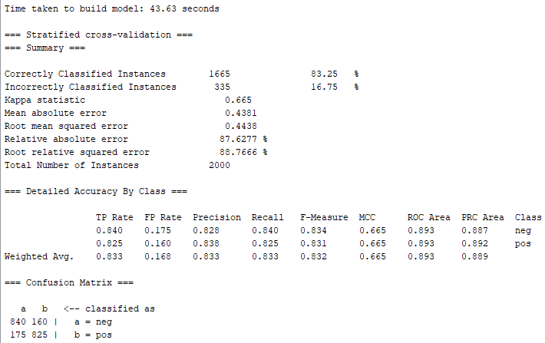
Chi Square + RF Iteration 300 + Adaboost, 10Fold
Lampiran 5
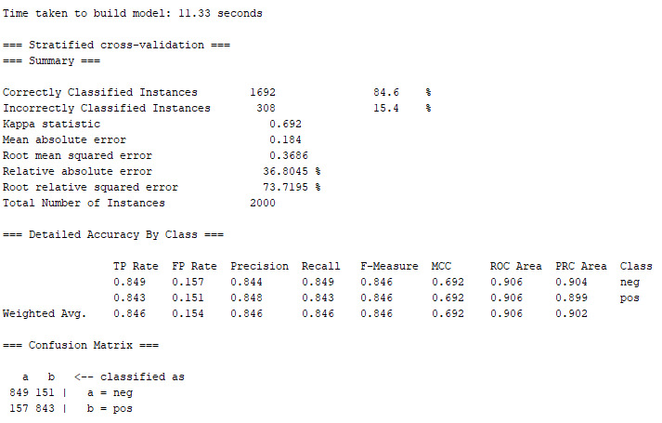
Chi Square + Vote (Maximum Probability + NB + SVM Radial Kernel), 8Fold

Lampiran 6.A
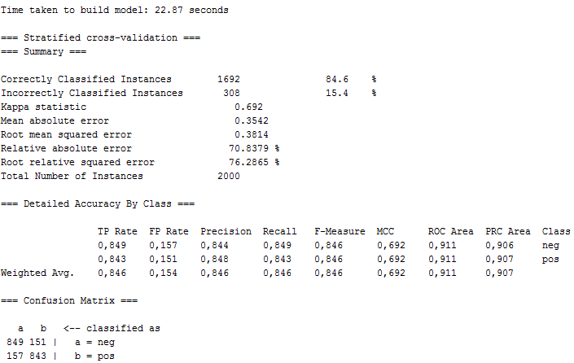
Chi Square + Vote (Maximum Probability + RF 300iteration + SVM RBF Kernel), 8Fold

Lampiran 7
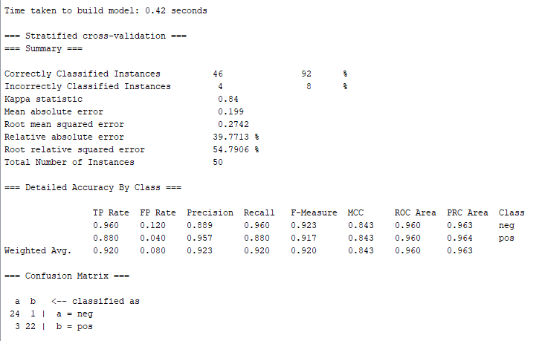
Ulasan bahasa Indonesia + Chi Square + Vote (RF 300iteration + SVM Radial Kernel), 8Fold

